**Description of the convertor project.**

In the zip file you will find the Visual Studio solution that can be opened with Visual Studio.

There are two project in the solution (IHIWS18Convertor.sln) : **IHIWS18Convertor** that contains the web-service and **IHIWS18ConvertorTest** that contains a form that can be used to test the service and the class.

**The web-service.**

The source of the service can be found in Convertor.asmx. Here you can find the data structure of the request and response.

The web-service also contains the class (IHIWConvertor.vb) that contains all the functions. There are three functions:

1. DetermineManufacturer. This function determines whether the files are well formed and if all the required fields are available. Returns “OneLambda” or “Immucor” if the function succeeds, otherwise the manufacturer will be empty.
2. ProcessOneLambda. Converts a OneLambda file to xml and returns the xml.
3. ProcessImmucor. Converts a Immucor file to xml and returns the xml.

In order to publish the web-service select the project in Visual Studio and select Publish.

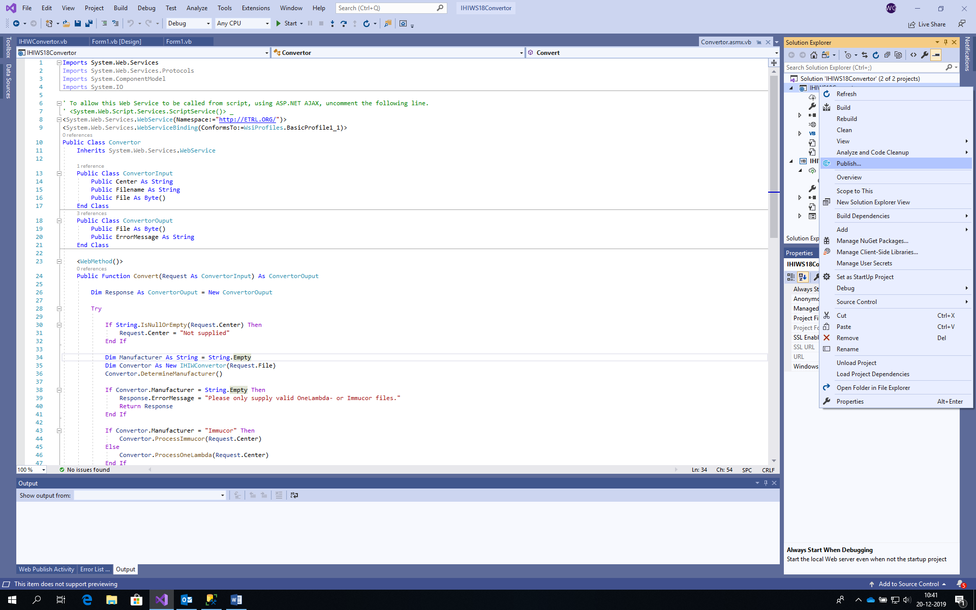

**IHIWSConvertotTest.**

For testing purposes I have created a small project that can test the class, or (if configured properly) can test a web service.

If you make a web service binding please note that you have to increase the maxReceivedMessageSize in App.config.

The application starts with a file-open dialog, converts the file and save the xml output in the directory C:\IHIWS18.

**Testing.**

There is also a directory with three files for testing included in the .zip file. The layout of the immucor files is under construction.

**The input files.**

The files have a specific layout.

The output of the **Fusion** (OneLambda) software can be made in this way:

Select ‘Reports’, ‘Tools’, ‘Setup Data Export’.  
Select:  
Patient – Patient ID  
Sample – Sample ID  
Session – Run Date  
Catalog – Catalog ID  
Catalog Detail – Bead ID  
Catalog Detail - Specificity  
Well Detail – MFI (Raw Data)  
Well – NC2 BeadID  
Well – PC2 BeadID  
Well detail - Rxn

Save the setup.

Select the data you wish to export. Select ‘Tools’, ‘Export data’. Select the export you created and saved before. Save the file as **CSV**.

For **MatchIt!** ((Immucor software) Christine Heylen is developing a tool for the workshop. Because this tool is not ready yet I am not certain what the exact names of the columns are going to be.

For now the positive and negative control are missing (which I solved temporarily by using the highest and lowest values) and there is an issue with the Patient ID. In the class I have used the column Patient Name, but that is not expedient. It seems that the patient ID can be in stored in two columns in MatchIt! (donor number and accession) and that users use both. Hopefully this will be solved in the export tool.